SHRI KRISHNASWAMMY COLLEGE
FOR WOMEN

TEAM ID : SWTID-2026-8000
TEAM SIZE : 5
TEAM LEADER : MAHALAKSHMI G
TEAM MEMBER : JANANI S
TEAM MEMBER : ESWARI S
TEAM MEMBER : KAVI PRIYA A
TEAM MEMBER : ABINAYA J

FitBuddy – AI Fitness Plan Generator using Gemini Models Project Description:
FitBuddy is a web-based application that uses AI to generate personalized workout plans and nutrition tips based on a user’s fitness goals, such as weight loss, muscle gain, or general wellness. Built with FastAPI and integrated with Google’s Gemini AI models, FitBuddy simplifies the process of creating structured and effective fitness routines.
The application takes in user information—like age, weight, goal, and preferred workout intensity—and generates a customized 7-day fitness plan. Users can also submit feedback to update and refine their plan using AI. A complementary nutrition or recovery tip is also provided based on their selected goal.
With a clean user interface and database support via SQLite, FitBuddy ensures each user's data and generated plan are stored and accessible. It offers both API endpoints and an interactive HTML interface for ease of use.

Scenarios:
Scenario 1 : A user inputs their personal details including name, age, weight, fitness goal (e.g., “weight loss” or “muscle gain”), and preferred workout intensity ( “high”, “medium” or “low”) to receive a personalized 7-day workout plan. The system generates a day-by-day schedule tailored to the user's fitness objective and experience level. This AI-driven customization enhances user motivation and adherence by providing structured and goal-specific routines.
Scenario 2: A user submits feedback on their existing workout plan, such as suggesting changes like “more focus on cardio” or “include more rest days.” The system uses this input to regenerate an updated workout plan, refining it based on the user's evolving needs. This feedback loop ensures that users stay engaged and receive dynamic fitness support as their preferences or progress change.
Scenario 3: A user requests a nutrition or recovery tip based on their selected fitness goal. The platform delivers a concise and relevant suggestion (e.g., “Include protein in your post-workout meal” for muscle gain), which complements the workout plan. These targeted tips help users improve results by aligning their diet and recovery practices with their physical training regimen.
Scenario 4: An admin or coach accesses the platform to view all registered users and their workout plans through a dedicated dashboard. This view allows them to track individual progress, compare original and updated plans, and monitor user activity. It streamlines oversight for trainers managing multiple clients or students.

Technical Architecture:

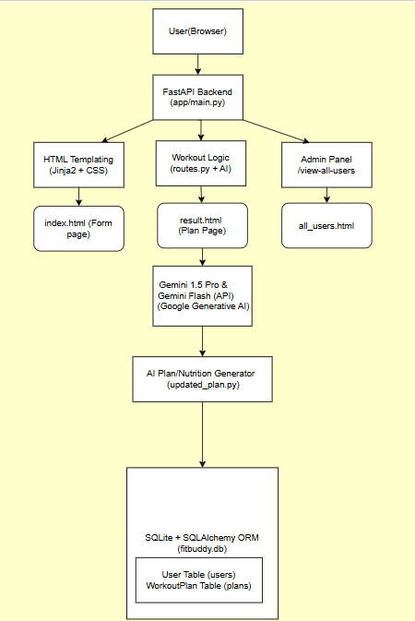

Pre - requisites:
- FastAPI Framework Knowledge: FastAPI Documentation
- Gemini API Familiarity: Google Generative AI Documentation
- HTML, CSS, and Jinja2 Template Skills: W3Schools HTML/CSS/Jinja2 Tutorials
- Python Programming Proficiency: Python Official Docs
- Version Control with Git: Git Documentation
- SQLAlchemy and SQLite Basics: : SQLAlchemy Docs
- Environment Setup (pip, virtualenv, or conda): Virtualenv Guide
- Uvicorn ASGI Server: Uvicorn Docs

Project Workflow:
Milestone 1. Model selection and Architecture
Activity 1.1. Research and Select the Appropriate Generative AI Model Activity 1.2. Define the architecture of the application
Activity 1.3. Set up the development Environment Milestone 2. Core functionalities Development
Activity 2.1. Develop the core functionalities
Activity 2.2. Implement the FastAPI Backend to Manage Routing and User Input Processing
Milestone 3. route.py Development
Activity 3.1. Writing the Main Application Logic in routes.py Milestone 4. Frontend Development
Activity 4.1. Designing and Developing User Interface
Activity 4.2. Creating Dynamic Templates with FastAPI’s Jinja2 Milestone 5. Deployment
Activity 5.1. Preparing the Application for Local Deployment Activity 5.2. Testing and Verifying Local Deployment

Milestone 1. Model selection and Architecture
In this milestone, we focus on selecting the appropriate generative AI models from Google’s Gemini family for the FitBuddy application. This includes evaluating the performance and capabilities of multiple Gemini models to ensure they align with the application’s core functionalities—such as generating personalized workout plans, updating them based on feedback, and providing tailored nutrition or recovery advice.

Activity 1.1: Research and Select the Appropriate Generative AI Model

Understand the Project Requirements

FitBuddy’s AI model needed to:
- Generate structured 7-day workout plans
- Provide concise and actionable nutrition tips
- Update workout plans based on user feedback
- Perform well in real-time, web-based interaction

Model Evaluation
We initially experimented with several Hugging Face models:
- T5 & BART – For text generation (workout/nutrition)
- DistilBERT – For potential intent classification
- Bloom – For general purpose generation

While these models showed promise in basic text generation, they had notable limitations. These models required:
- Hosting with Hugging Face or local GPU setup
- Fine-tuning or complex prompting to achieve structured plans

Final Model Selection
After comparative testing, we selected Google Gemini models for production:
- Gemini 1.5 Pro
→ Used for structured 7-day workout generation and plan updating
→ Delivers rich, context-aware, formatted responses reliably
- Gemini Flash
→ Used for generating fast, practical nutrition tips
→ Lightweight and efficient for quick API calls Reasons for Choosing Gemini:
- API-based, easy to integrate with FastAPI
- Naturally understands structured formatting (days, sections)
- High accuracy with minimal prompt tuning
- Scalable and fast for feedback-based revisions

Activity 1.2.Define the architecture of the application

Architecture Overview: FitBuddy follows a modular FastAPI-based architecture-
- Frontend: HTML + Jinja2 templates for user input and display
- Backend: FastAPI for route handling and logic
- AI Layer: Google Gemini APIs (Pro & Flash)
- Database: SQLite with SQLAlchemy for persistence Frontend Responsibilities: Users interact via-
- index.html – Input form
- result.html – Plan, tip, feedback
- all_users.html – Admin panel
Backend Responsibilities:

- Receives form data
- Calls Gemini models
- Stores user info and plans
- Renders dynamic templates AI Integration Points:
- Workout generation & feedback updates → Gemini Pro
- Nutrition tips → Gemini Flash

Activity 1.3 Set up the development Environment:
Install Python & Pip: Ensure Python and pip are installed.

Create Virtual Environment:
python -m venv fitbuddy-env
fitbuddy-env\Scripts\activate (Windows)

Install Required Libraries:
pip install fastapi uvicorn jinja2 sqlalchemy python-multipart google-generativeai

Run Server:
uvicorn app.main:app --reload
Visit http://127.0.0.1:8000 for the app and /docs for API testing.

Set Up Project Structure:
Create folders: /app (Python files), /templates (HTML), /static/images (assets)
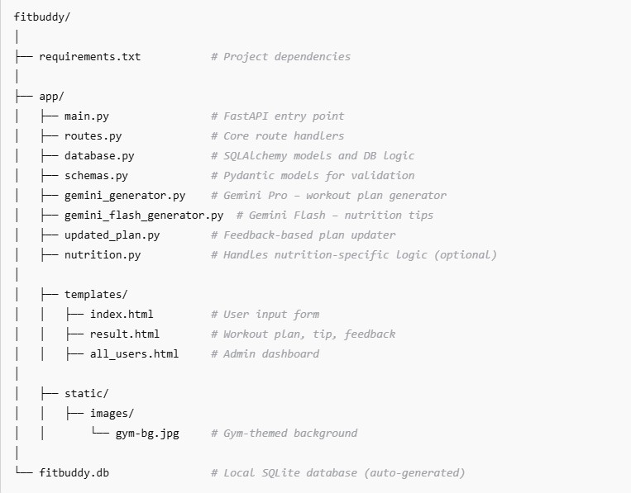

Milestone 2. Core functionalities Development Activity 2.1 Develop the core functionalities:

Workout Plan Generation
Function: generate_workout_gemini() File: gemini_generator.py
Implements the core logic to generate a personalized 7-day workout plan using user inputs such as goal (e.g., muscle gain, weight loss) and intensity (low, medium, high). The prompt is sent to the Gemini 1.5 Pro model, which returns a structured, day-wise plan including:
- Warm-up (5–10 mins)
- Main workout (exercise details, sets, reps)
- Cooldown or recovery tip
The output is returned to routes.py and rendered on the result.html page using <pre> blocks for formatting.

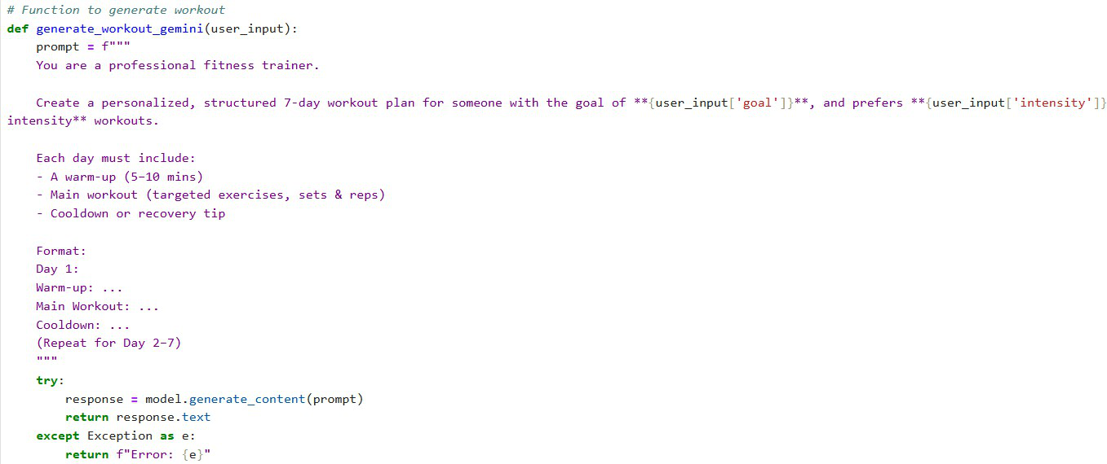

Nutrition Tip Generation
Function: generate_nutrition_tip_with_flash() File: gemini_flash_generator.py
This function generates a concise, practical nutrition or recovery tip tailored to the user’s selected goal. It utilizes the Gemini Flash model to deliver a fast, helpful response such as hydration advice, protein suggestions, or general recovery best practices. This tip is displayed beneath the workout plan in result.html.
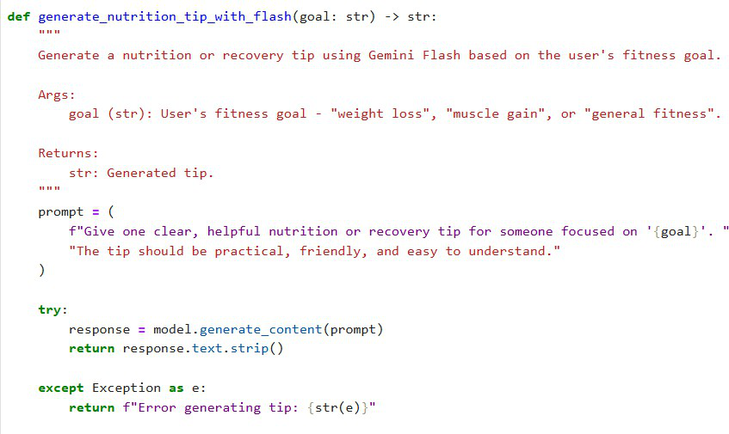

Feedback-Based Plan Updating
Function: update_workout_plan() File: updated_plan.py
This function enables the user to revise their original plan by submitting feedback (e.g., "Add yoga", "Include more cardio"). The original plan and feedback are passed to Gemini 1.5 Pro, which returns a modified plan with the suggested updates. The updated plan is then stored and displayed alongside the new nutrition tip.
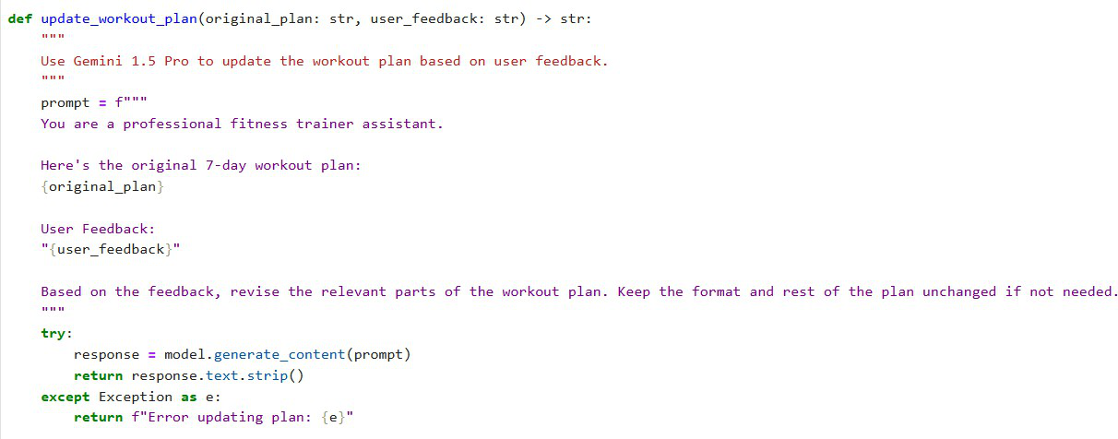

User & Plan Storage
Functions:
- save_user(), save_plan(), update_plan()
- get_original_plan(), get_user()

File: database.py

All user information (ID, name, age, weight, goal, intensity) and AI-generated plans are stored in a SQLite database via SQLAlchemy ORM. Feedback-based updates are saved as a separate field to preserve both versions (original and updated).

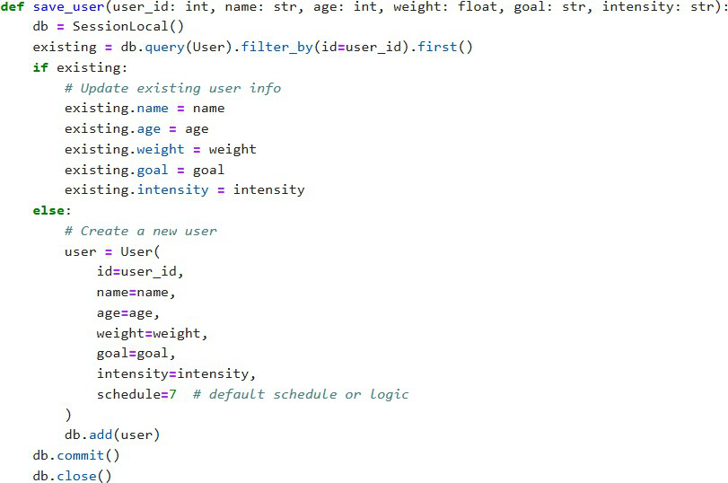

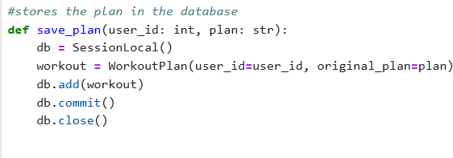

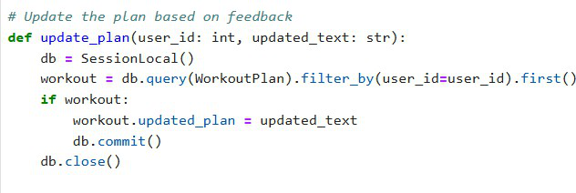
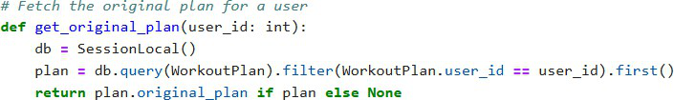

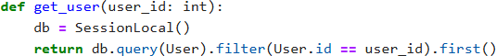

Admin View of All Users
Route: /view-all-users Template: all_users.html
Displays a list of all users and their respective plans. Rendered with Jinja2 using a {% for user in users %} loop, it allows administrators to see original and updated plans clearly in a structured table format.

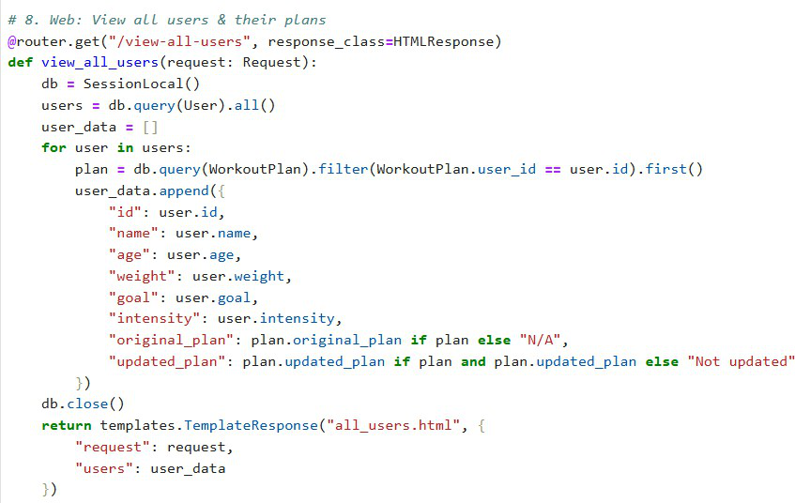

Activity 2.2: Implement the FastAPI Backend to Manage Routing and User Input Processing

Define Routes in FastAPI

All routing logic is handled in routes.py. Each route is linked to the corresponding function developed in Activity 2.1.

Process User Input
- HTML Form: Created in index.html
- Users enter: username, user_id, age, weight, goal, and intensity
- FastAPI captures inputs using Form(...) parameters
- Pydantic schemas (UserInput, FeedbackRequest) are used to validate structure

Integrate Gemini API Calls
Each route handler connects directly to the respective Gemini-powered function:
- /generate-workout →
  - generate_workout_gemini() for workout plan
  - generate_nutrition_tip_with_flash() for tip
- /submit-feedback →
  - Retrieves plan
  - Sends original + feedback to update_workout_plan()
All AI-generated responses are returned cleanly and injected into the frontend templates for display.

Milestone 3. routes.py Development
Milestone 3 focuses on building the routing logic inside the routes.py file, which acts as the core operational layer of the FitBuddy application. It bridges the frontend templates, AI generation modules (Gemini Pro and Flash), and the SQLite database. Each route defines how user inputs are collected, processed, and responded to — creating a dynamic, personalized experience for fitness planning and feedback-based updates.

Activity 3.1: Writing the Main Application Logic in routes.py

Defining Core routes in routes.py:
Separate routes were implemented to serve each of FitBuddy’s main functionalities:
- / : Displays the user form via index.html
- /generate-workout: Processes user input and generates a personalized workout plan
- /submit-feedback: Updates the workout plan based on user feedback
- /view-all-users: Displays an admin dashboard showing all users and their plans

Set up Route Handlers for Each Feature
➤ / – Home Route
  - Returns the homepage (index.html)
  - No form processing logic
➤ /generate-workout – Plan Generator
  - Receives user input using FastAPI’s Form(...)
  - Constructs a UserInput Pydantic model
  - Calls:
    - generate_workout_gemini(...) → Generates workout plan via Gemini 1.5 Pro
    - generate_nutrition_tip_with_flash(...) → Gets nutrition tip via Gemini Flash
  - Stores:
    - User details with save_user(...)
    - Plan with save_plan(...)
  - Returns result.html with dynamic data
➤ /submit-feedback – Update Plan with Feedback
  - Captures feedback and user_id
  - Retrieves original plan from DB
  - Uses update_workout_plan(...) to revise the plan via Gemini 1.5 Pro
  - Updates the revised plan in the DB using update_plan(...)
  - Renders updated result on result.html

➤ /view-all-users – Admin View
  - Calls get_all_users() and get_all_plans() to fetch DB records
  - Passes them to all_users.html
  - Admin can view:
    - Username, Age, Weight, Goal, Intensity
    - Original and updated workout plans

Integrate Gemini AI Responses in Each Function
Each AI-related route calls Google’s Gemini models with specific prompts:
  - Workout Plan Generation:
generate_workout_gemini() sends fitness goal and intensity to Gemini Pro to return a structured 7-day workout plan.
  - Nutrition Tip Generation:
generate_nutrition_tip_with_flash() uses Gemini Flash to generate a practical tip related to the user’s fitness goal.
  - Workout Plan Update via Feedback:
update_workout_plan() passes original plan + user feedback to Gemini Pro and returns a revised plan.
All responses are returned to the user through result.html, maintaining clarity using <pre> blocks for formatting.

Workout generation route Nutrition/Recovery tip generation route

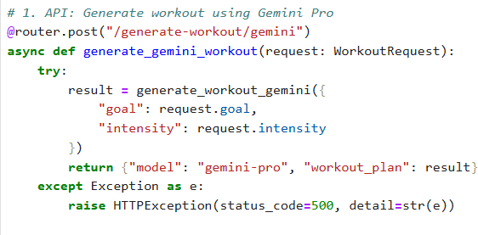

Nutrition/Recovery tip generation route

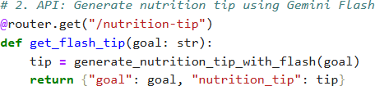

Saving user info and plan generation route

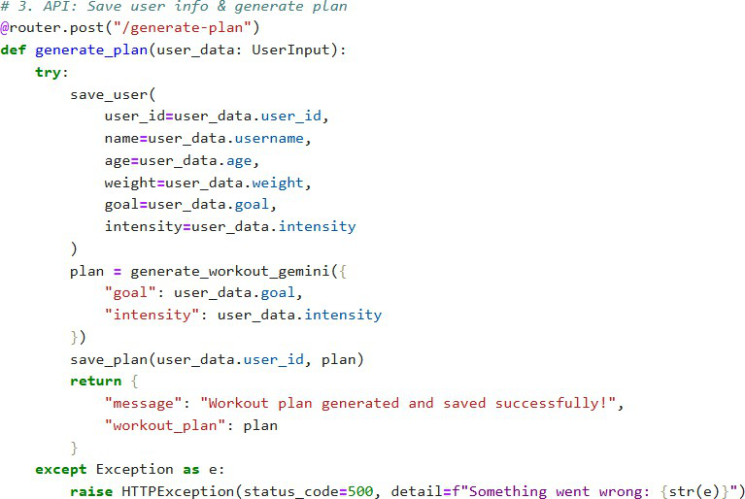

Submit Feedback and update plan route

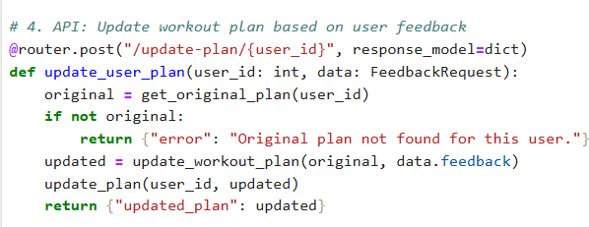

Milestone 4. Frontend Development
Milestone 4 focuses on developing a user-friendly and visually structured interface for FitBuddy, the AI-powered workout generator. This involves building responsive and interactive web pages using HTML, CSS, and Jinja2 templating. Each template is dynamically rendered through FastAPI, ensuring users can easily submit input, receive personalized plans, provide feedback, and allow administrators to manage data effectively. This milestone guarantees an engaging and intuitive fitness planning experience for all users.

Activity 4.1 Designing and Developing the User Interface

Set Up the Base HTML Structure

- Developed index.html as the main entry point for user input.
- Structured the form to capture:
  - username, user_id, age, weight, goal, and intensity.
- Each field is properly labeled and grouped using semantic HTML.
- The design uses a gym-themed background image, Google Fonts (Roboto), and bold typography to create a clean, fitness-oriented interface.
- Navigation is kept minimal for focus, and user flow directs clearly from input to output.

Design a Responsive Layout Using CSS

- Embedded CSS styles were applied directly in each HTML file.
- Layouts use Flexbox to center content both vertically and horizontally.
- Media queries ensure mobile responsiveness.
- Buttons have consistent styling with hover effects.
- Input fields and result blocks have adequate padding, shadows, and rounded corners for modern aesthetics.
- Overall color scheme supports readability on a dark background.

Create Separate Pages for Each Core Functionality

Three Jinja2-powered HTML templates were created under /templates:
- index.html: A user input form with fields for fitness goal, intensity, and basic personal information.
- result.html: Displays the 7-day AI generated workout plan, a nutrition tip, and accepts user feedback.
- all_users.html: Admin panel to view and delete users and review both original and updated plans.
Templates are modular, and UI transitions smoothly between steps. Forms are submitted to specific FastAPI endpoints via POST methods

Activity 4.2 Creating Dynamic Templates with FastAPI’s Jinja2

Integrate Jinja2 Templating for Dynamic Content Rendering
- Used FastAPI’s Jinja2Templates for template rendering:
from fastapi.templating import Jinja2Templates BASE_DIR = os.path.dirname(os.path.abspath( file )) TEMPLATE_DIR = os.path.join(BASE_DIR, "templates") templates = Jinja2Templates(directory=TEMPLATE_DIR)
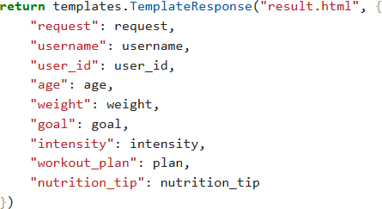
  - This allows dynamic plan and nutrition tip display after form submission.

Bind Backend Data to HTML Templates
➤ index.html
- Form elements use name="..." to bind to backend Form(...) parameters.
- Submits data to /generate-workout.

➤ result.html
- Uses:
- {{ username }}, {{ goal }}, {{ intensity }}, etc. to show user data.
- {{ workout_plan }} and {{ nutrition_tip }} to show AI-generated results.
- Includes a feedback form submitted via POST to /submit-feedback.
➤ all_users.html
- Loops over all user records using:

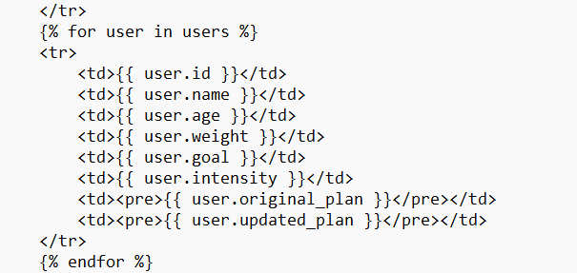

Milestone 5. Deployment
Now, the focus is on deploying the FitBuddy application on a local system using FastAPI and Uvicorn. The app uses HTML templates rendered with Jinja2, alongside AI services powered by Gemini. This milestone ensures all environment dependencies are correctly installed, and the app runs smoothly on a local server, preparing it for future deployment on cloud platforms.

Activity 5.1: Preparing the Application for Local Deployment

Set up a virtual environment
- Create a virtual environment to manage dependencies and isolate the FitBuddy project from other environments.
- Activate the environment and install all necessary dependencies listed in the requirements.txt file, including FastAPI, Uvicorn, SQLAlchemy, and Google Generative AI SDK.
python -m venv venv
source venv/bin/activate # On Windows: venv\Scripts\activate pip install -r requirements.txt

Configure environment variables
- Use environment variables to store sensitive data such as the Gemini API Key.
- These variables can be set directly in the terminal or added to a .env file which is loaded into the application using python-dotenv.
GOOGLE_API_KEY=your_gemini_api_key_here

Frontend-Backend Rendering via Jinja2
All user interactions are facilitated via Jinja2-rendered templates:
- index.html: Collects user inputs

Milestone 5. Deployment
Now, the focus is on deploying the FitBuddy application on a local system using FastAPI and Uvicorn. The app uses HTML templates rendered with Jinja2, alongside AI services powered by Gemini. This milestone ensures all environment dependencies are correctly installed, and the app runs smoothly on a local server, preparing it for future deployment on cloud platforms.

Activity 5.1: Preparing the Application for Local Deployment

Set up a virtual environment
- Create a virtual environment to manage dependencies and isolate the FitBuddy project from other environments.
- Activate the environment and install all necessary dependencies listed in the requirements.txt file, including FastAPI, Uvicorn, SQLAlchemy, and Google Generative AI SDK.
python -m venv venv
source venv/bin/activate # On Windows: venv\Scripts\activate pip install -r requirements.txt

Configure environment variables
- Use environment variables to store sensitive data such as the Gemini API Key.
- These variables can be set directly in the terminal or added to a .env file which is loaded into the application using python-dotenv.
GOOGLE_API_KEY=your_gemini_api_key_here

Frontend-Backend Rendering via Jinja2
All user interactions are facilitated via Jinja2-rendered templates:
- index.html: Collects user inputs
- result.html: Displays the generated AI plan
- all_users.html: Lists all user records for admin view
- Activity 5.2: Testing and Verifying Local Deployment Access the Application Locally
The FastAPI development server must be started using the command (uvicorn main:app
—reload). Once the server is running, the application can be accessed through any web browser by navigating to http://127.0.0.1:8000. This URL loads the main user interface where individuals can input their details and generate personalized fitness plans. Additionally, the interactive API documentation provided by FastAPI can be viewed at http://127.0.0.1:8000/docs, allowing developers to explore and test available endpoints.

